**Work with Git on VS Code**

* Initialize Repository

Open fold in vs code and click initialize repository

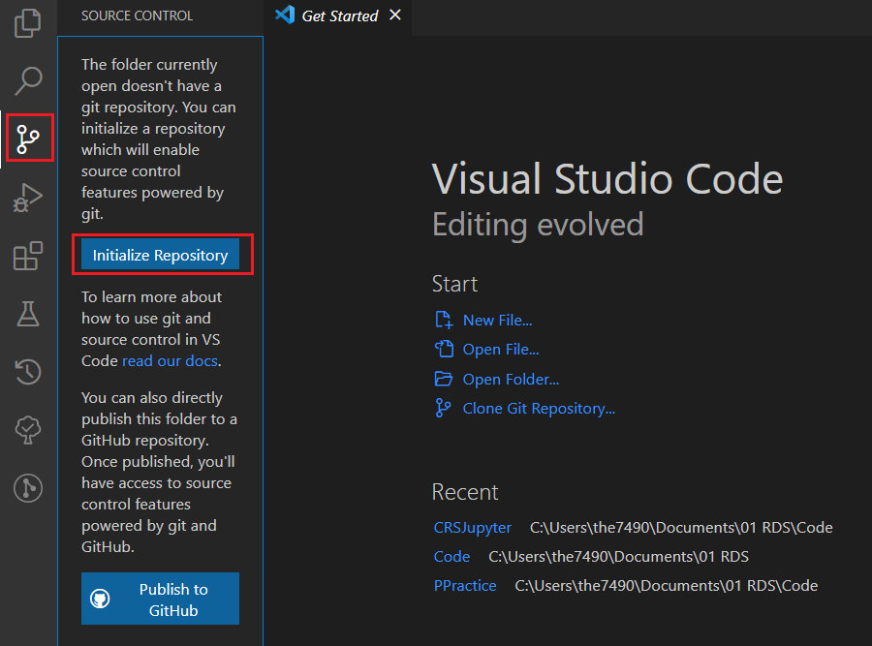

* Creating Snapshots

View all changes in source control panel

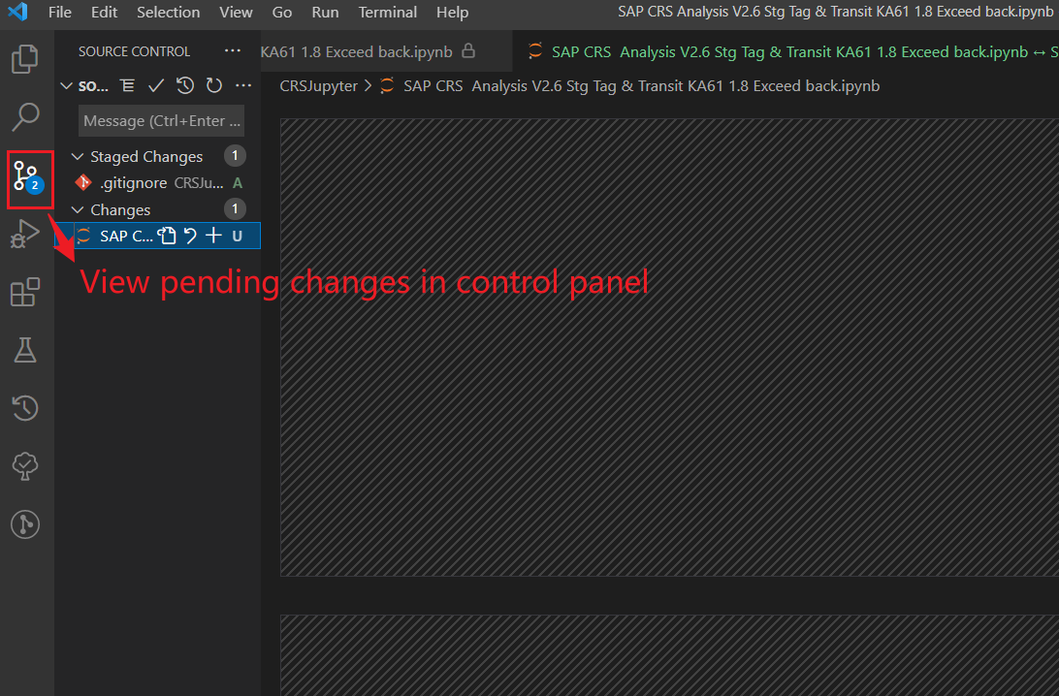

Add to staging area

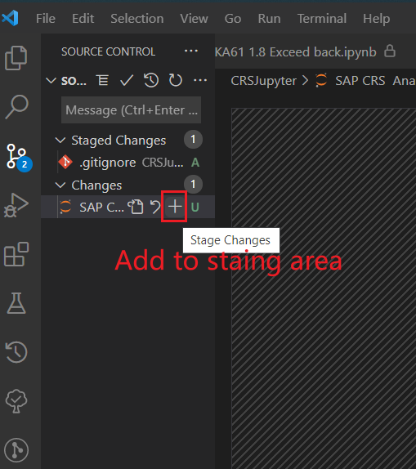

Un-stage file

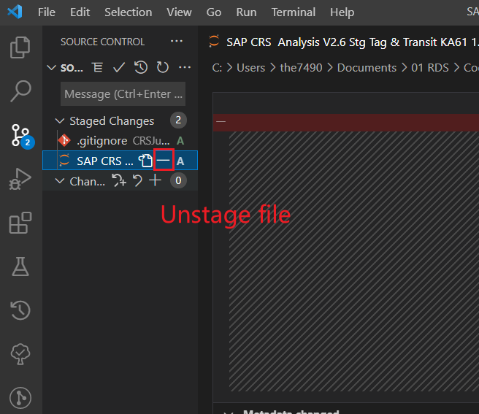

Add comments and commit

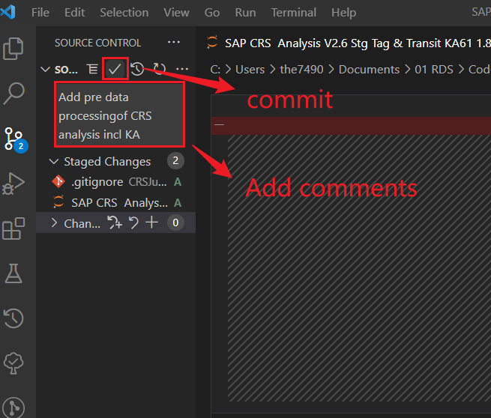

Check previous commits and corresponding changes on file

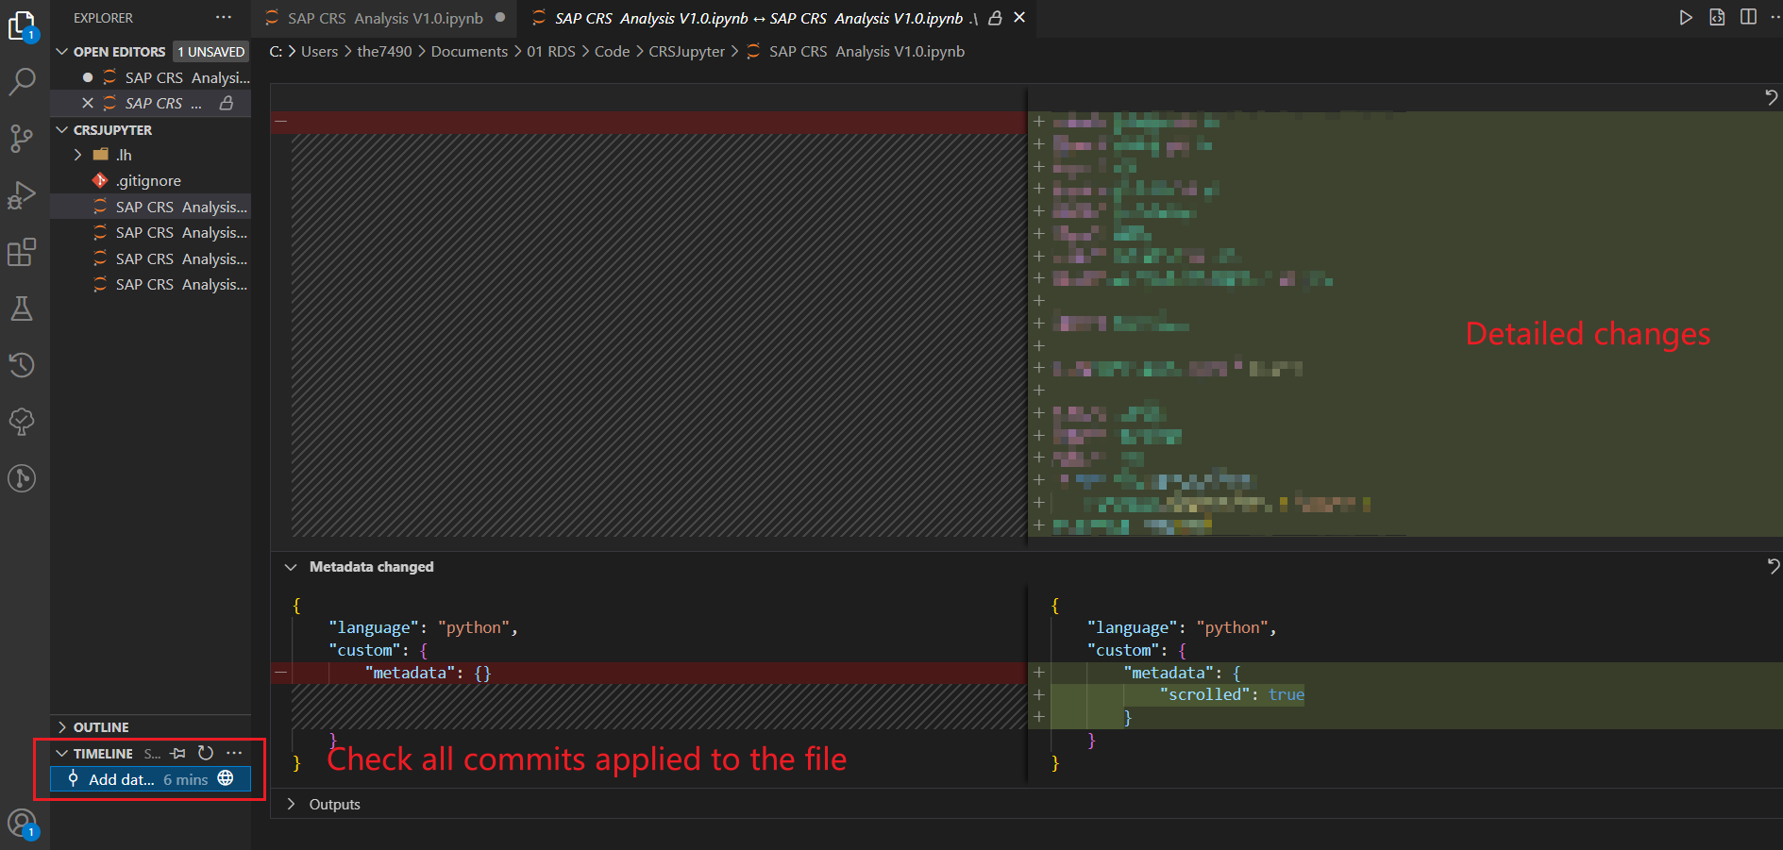

* Browsing history

*Get a extension GitLens

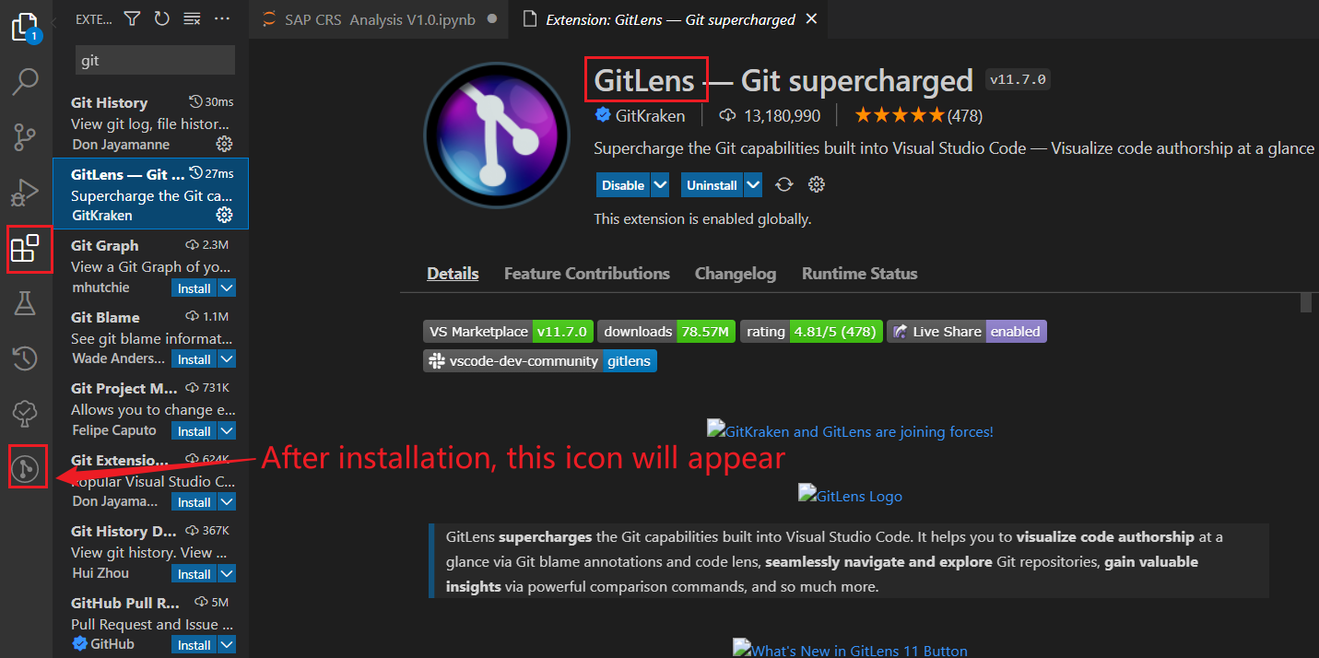

Click repositories and click branches for each commit, hover on it to see detailed information such as author, commit time, number of modified files

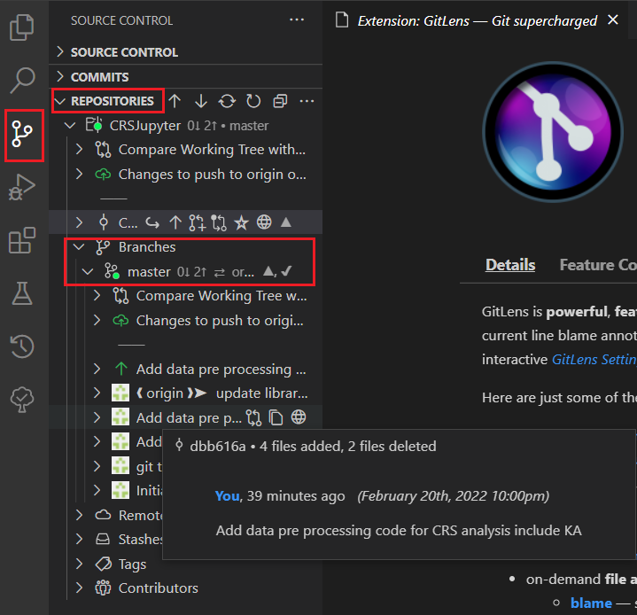 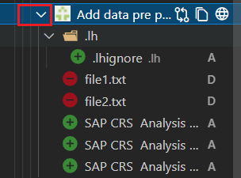

In command palette, apply git tag to modify tags

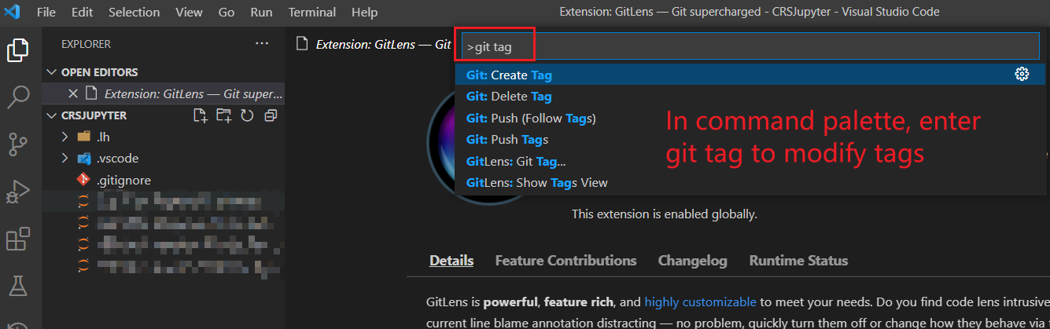

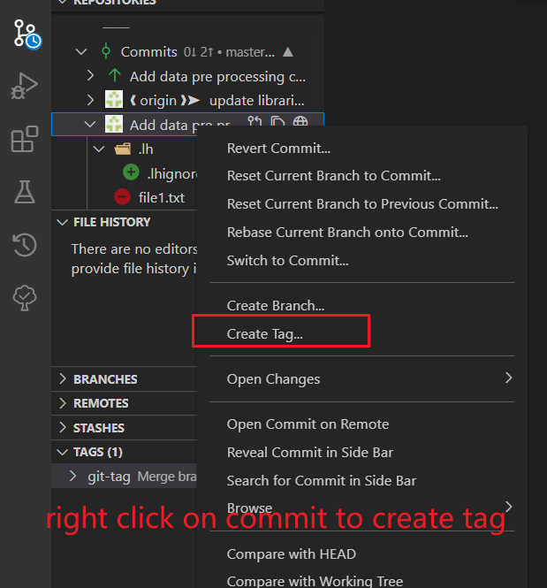

* Branching

Right click on branches to create a new branch

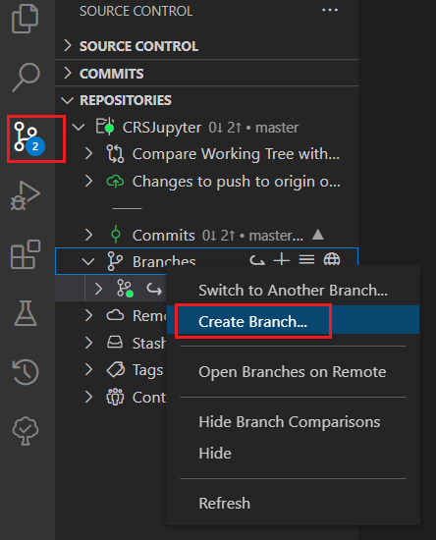

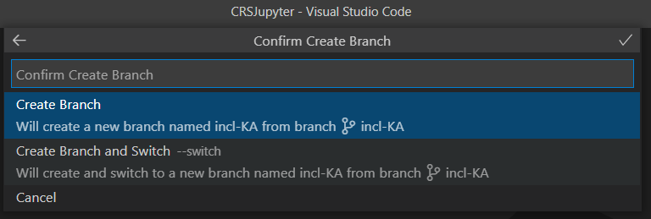

Click on the branch and choose the other branch want to compared with such as master

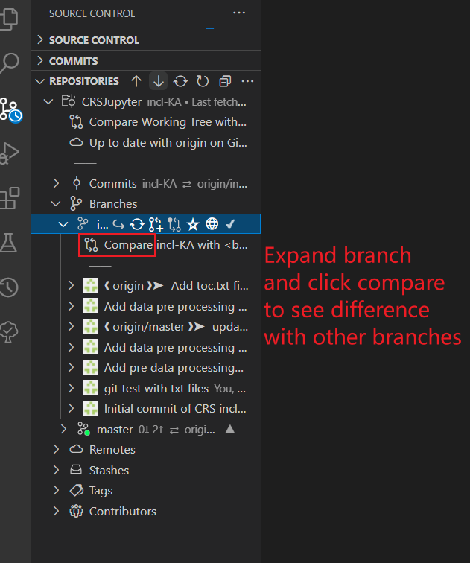

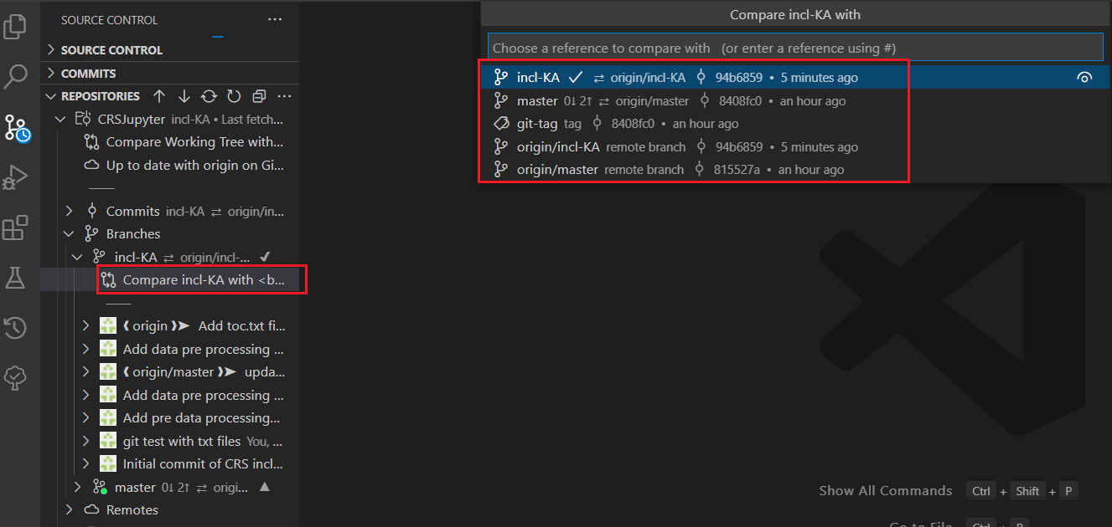

Switch to master branch and then click merge branch into current branch (master)

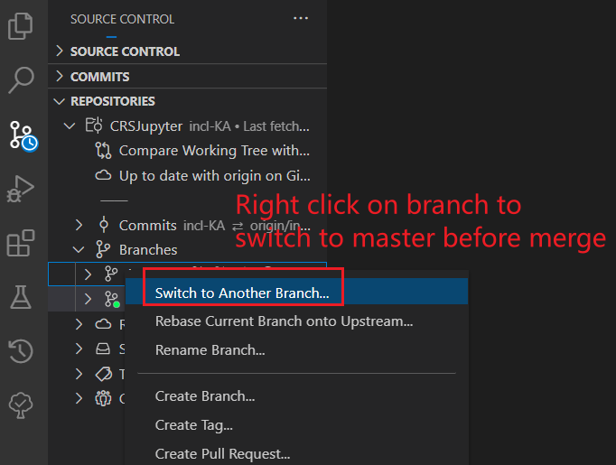

Right clic on branch again and select merge

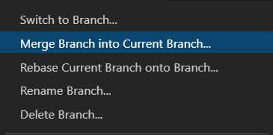

Select merge

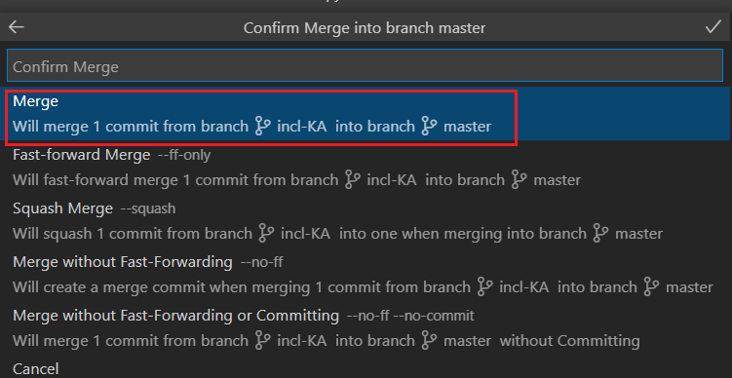

*If there’s a conflict, it will appear in changes for user to decide which one to keep.

Go to source control and commit the merge

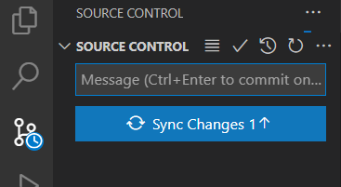

Redo the commit

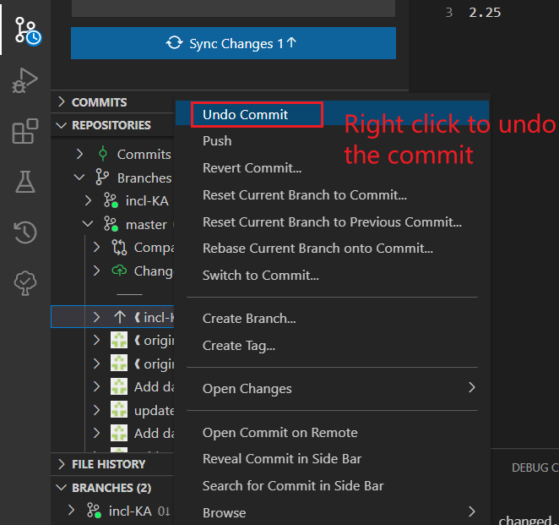

*Extension Git Graph provides commits more vividly

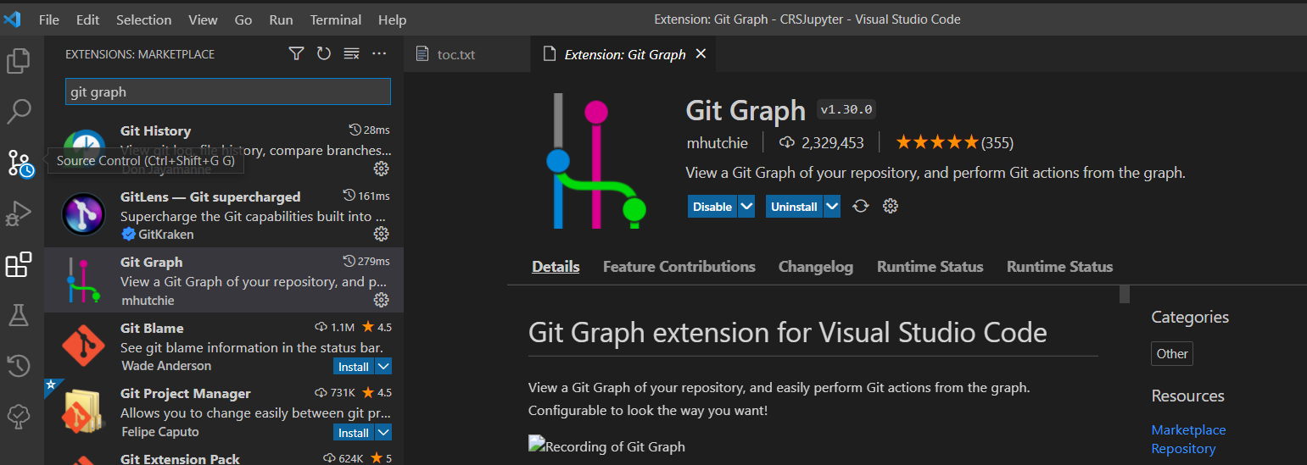

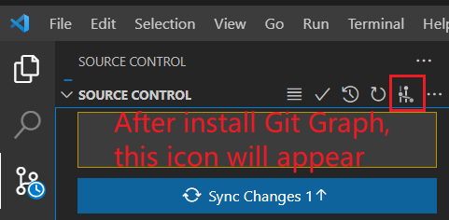

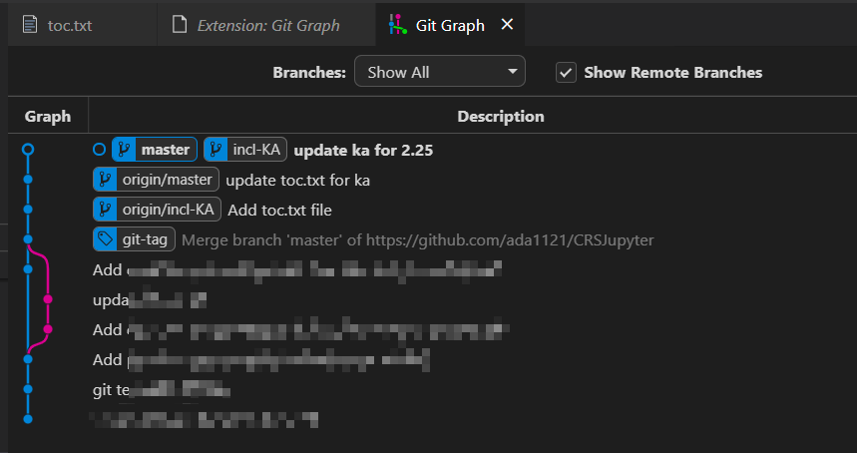

* Collaboration

Go to repositories and right click on one of the repository to fetch/pull/push

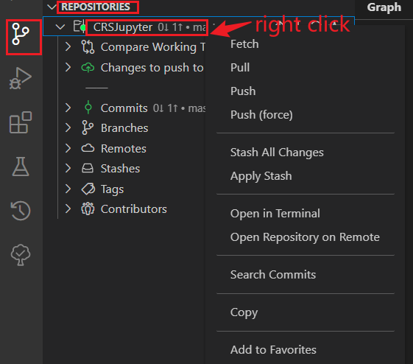

Right click on commit to push

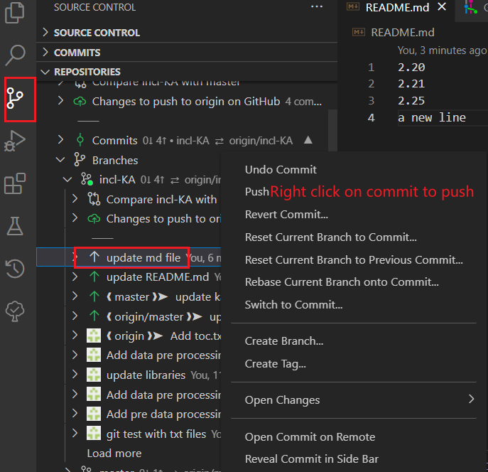

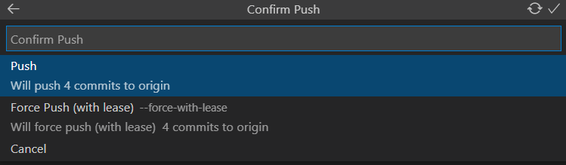

* Rewrite History